Calculator−assumed Solutions

11. (a) The number of phones she is given to repair for the week.
(b) She fixes 23 per day, for 4 days 23 x 4 = 92 phones
(c) 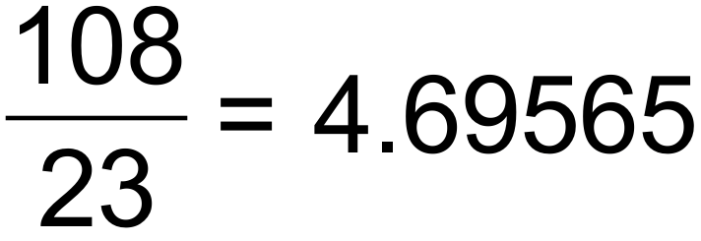 days
hours
5 hours and 34 minutes
(d) T₁ =155 T₂ = 128 T₃ = 99 T₄ =68
T_{n+1} = T_{n} – (25 +2n) T₀ = 180 [6]

12. (a) 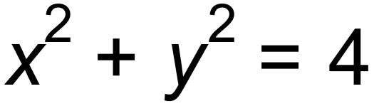
(b)  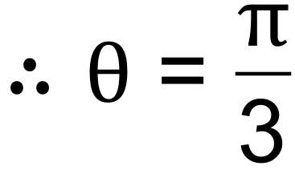 radians
radius = 2 units
(c) 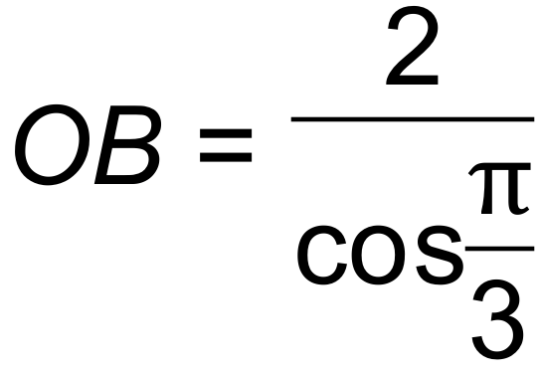 = 4
Therefore area of ΔAOB = 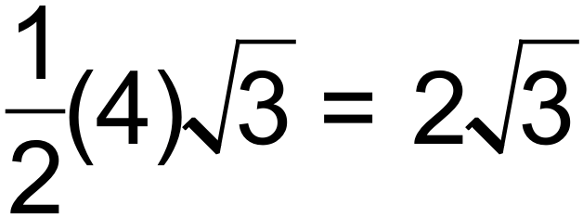 units²
Area of sector = 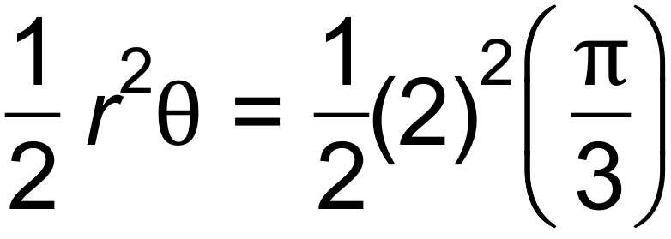
= 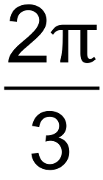 units²
Area of shaded part = triangle – sector
= 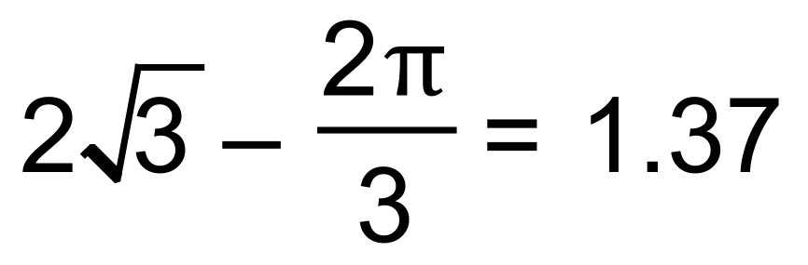units² (3 sig fig) [6]

13. (a) 5.1 seconds
(b) 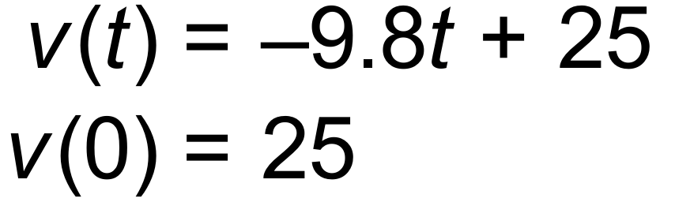
(c) Maximum height is 31.89 m when 
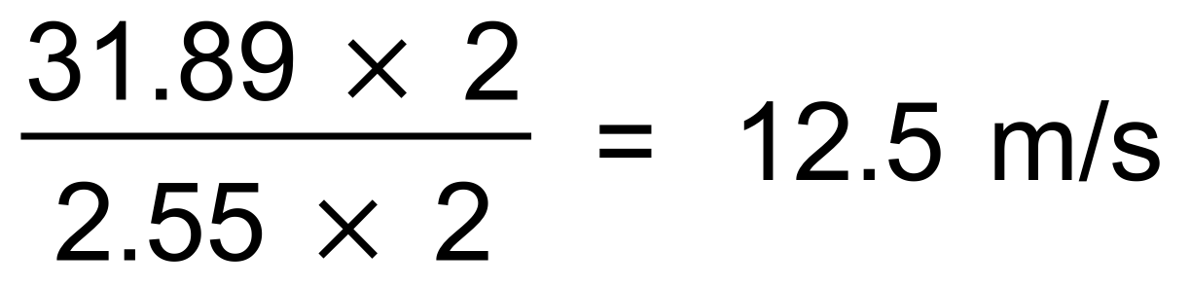 [5]

14. (a) 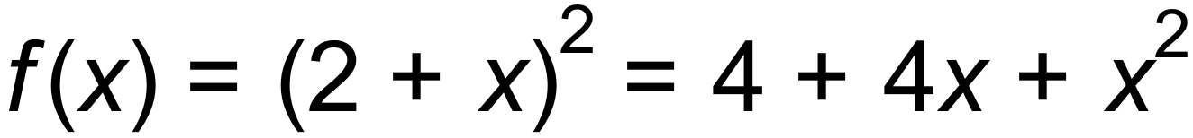
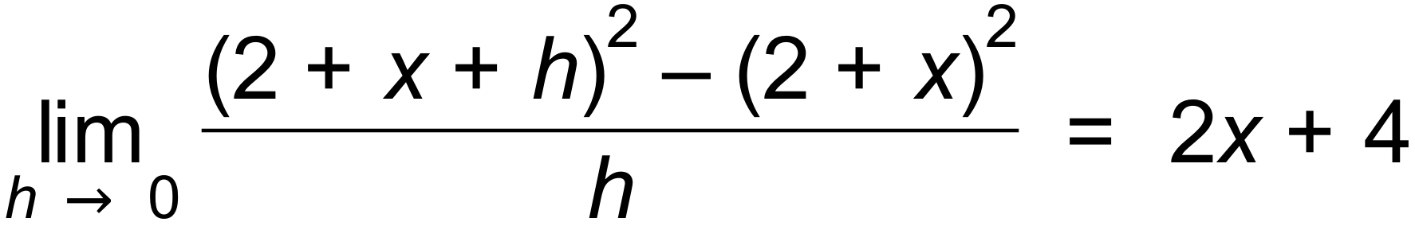
(b) (i) 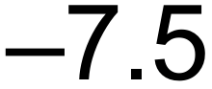
(ii) 18
(c) 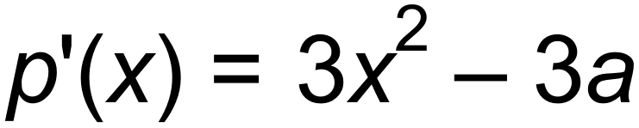
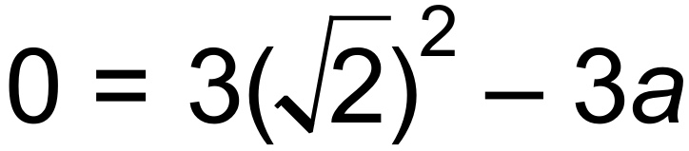
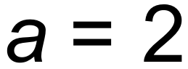
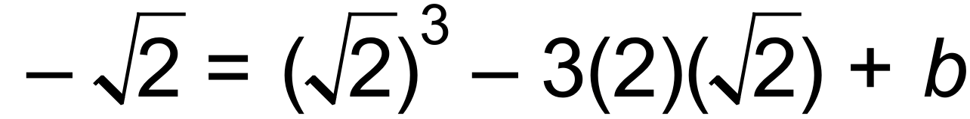
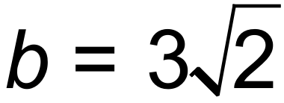 [7]

15. (a) 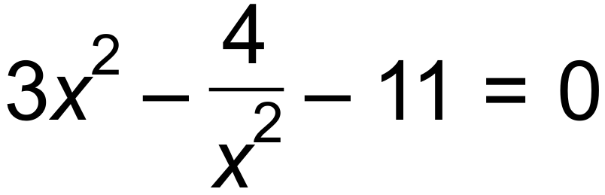


 |  | 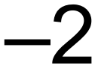 |  | 2
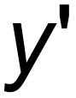 | + | 0 |  | 0 | +
y | ↑ | - | ↓ | - | ↑
(b)

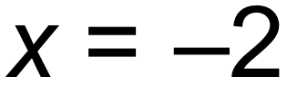 Maximum
 Minimum
(c) 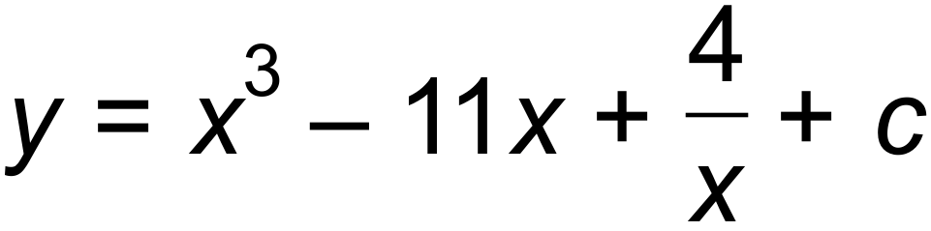
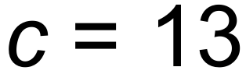
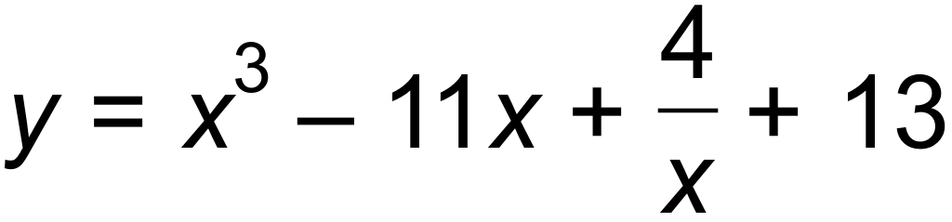
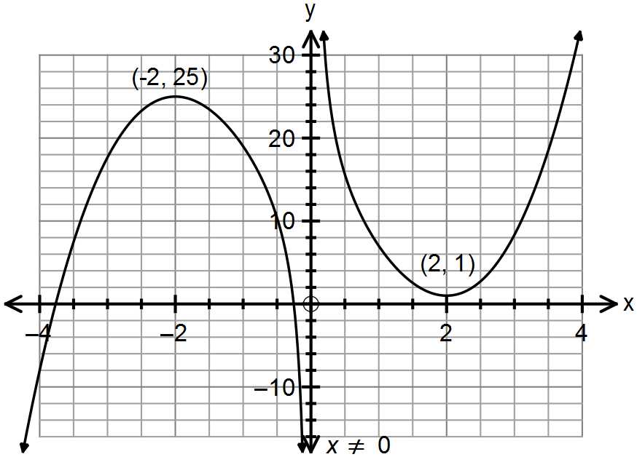(d)

[10]

16. (a) (i) T₁₀₀ = 23 +(99)(9)
= 914
(ii) 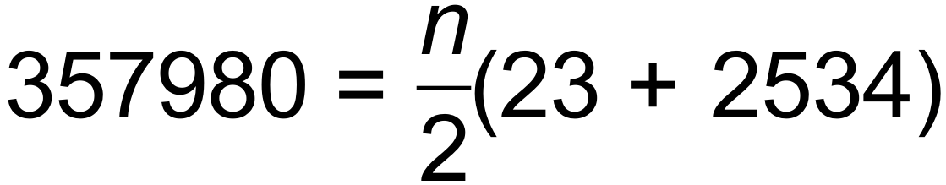

(b) (i) T_{n+1} = T_{n} T₁ = 12
(ii) 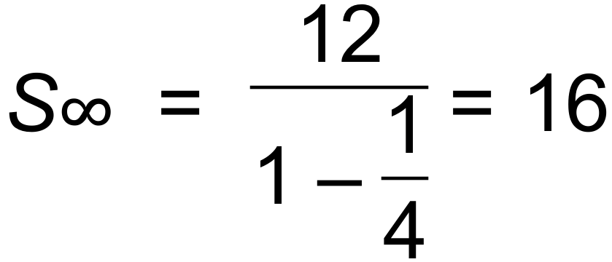 [8]

17. (a) 92°C (initial temp of tea)
22°C (room temp)
(b) After 4.12 mins and before 7.45 mins
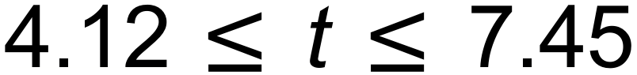
(c) Horizontal asymptote 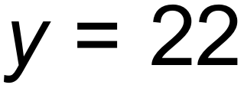
The tea will cool at a decreasing rate as it approaches room
temperature which is 22°. [6]

18. (a) 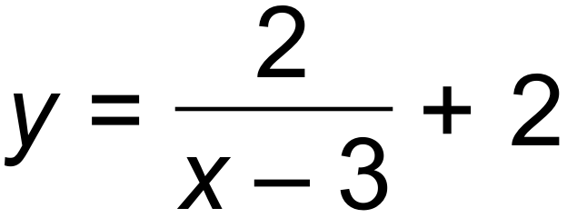
(b) 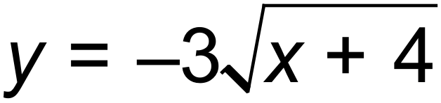
(c) 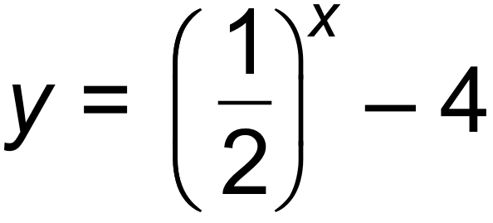 [6]

19. (a) 0.2
(b) 0.5
(c) 0.3
(d) Pr(X  Y) = Pr(X) x Pr(Y) if independent
Pr(X  Y) = Pr(X) + P(Y) - Pr(X  Y)
Pr(X) + Pr(Y) - Pr(X  Y) = Pr(X) x Pr(Y)
Let Pr(Y) = k
0.5+ k - 0.8 = 0.5k
k = 0.6 = Pr (Y) [6]

20. (a) 1, 3, 7, 15,…
T_{n+1} = T_{n} + 2^{n} T₁ = 1
(b) 20 sets [3]

21. (a) (i) 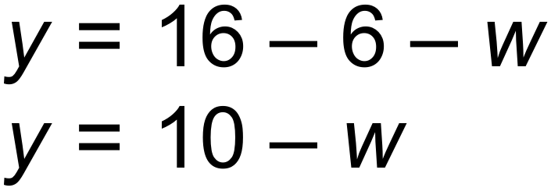
(ii) 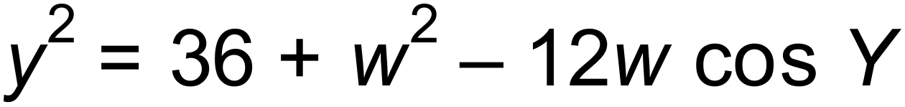
(iii)
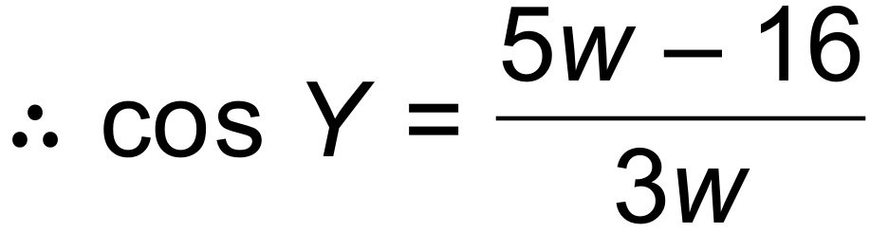
(b) (i) 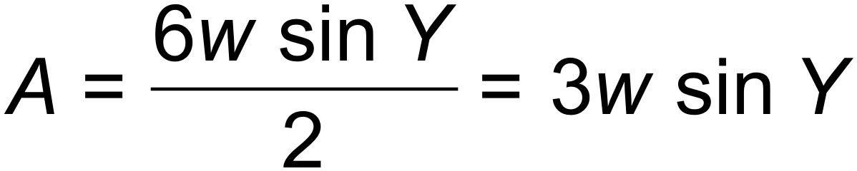
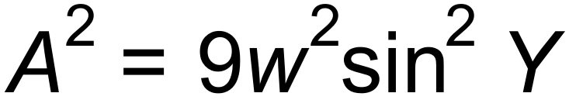
(ii) 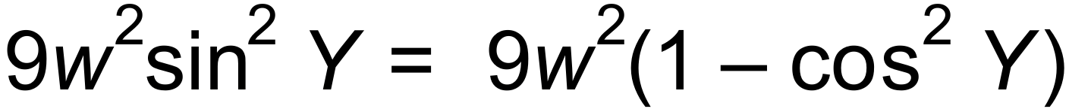
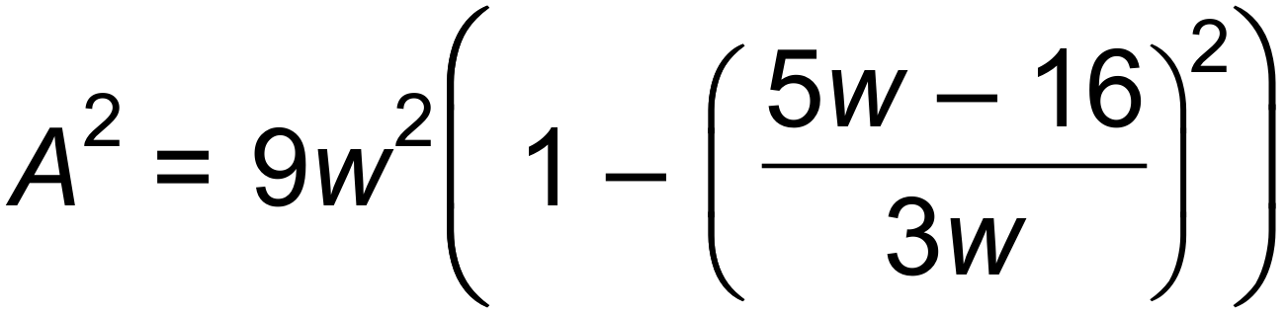
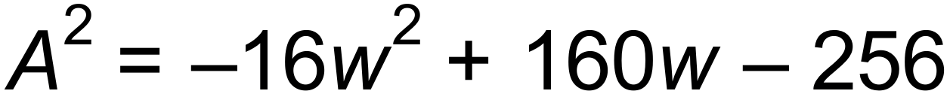
(c) (i) 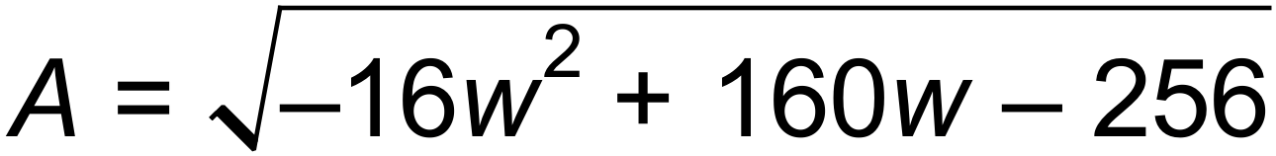

Maximum area = 12 units²
(ii) 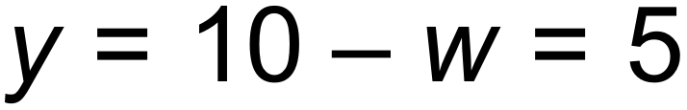
The triangle is isosceles. [12]

22. 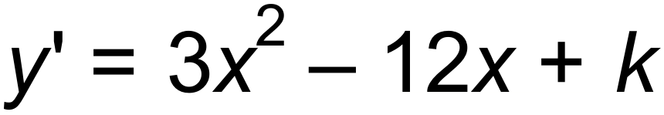
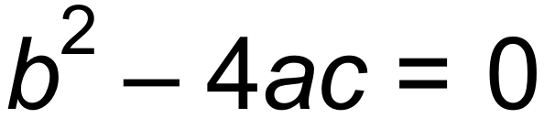 for one solution
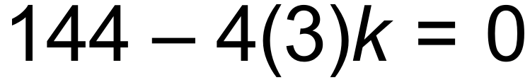
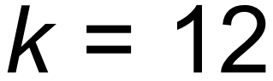 [3]

23. (a) W = W₀ (1.085)^{t}
R = R₀ (0.95)^{t}
10W₀ = R₀
W₀ (1.085)^{t} = 10 x W₀ (0.95)^{t}
(1.085)^{t} = 10(0.95)^{t}
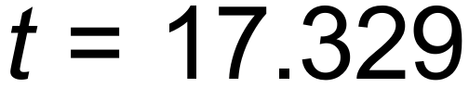 years
After 18 years there will be more wallabies.
(b) W_{n+1} = 1.085 W_{n} W₀ = 655
W₅ = 985 [5]

24. (a) 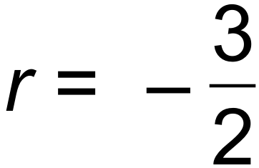
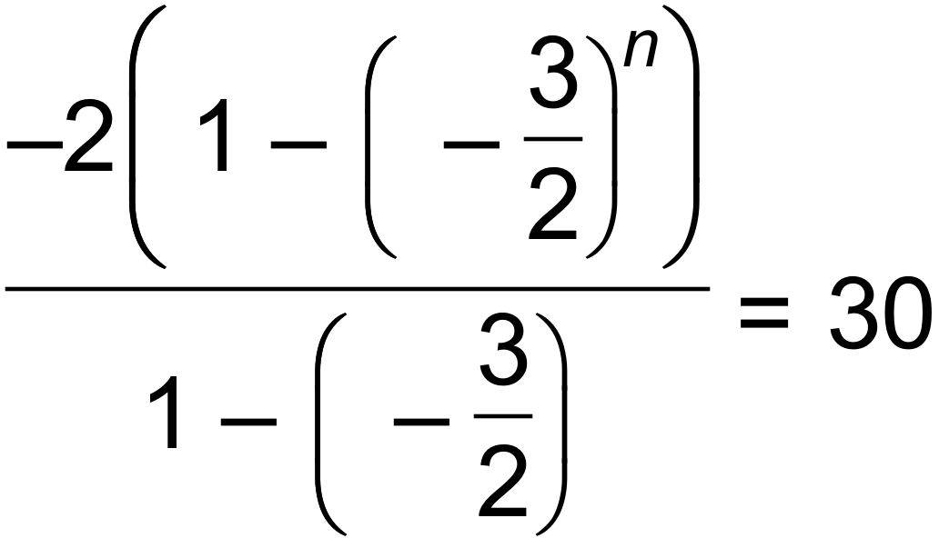
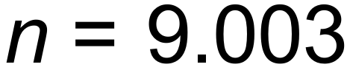

(b) T₅ = 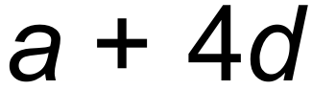 and T₇ = 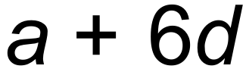
 (eq 1)
S₁₅ 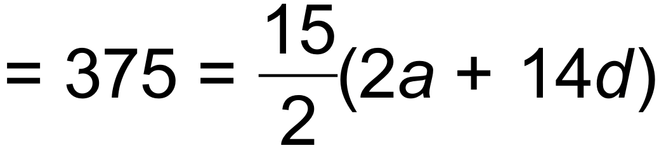 (eq 2)
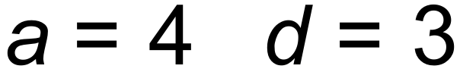
S₃₀ 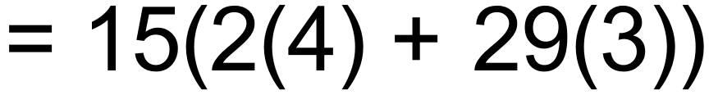 = 1425
Sum of next 15 terms = S₃₀  S₁₅ = 1050 [7]

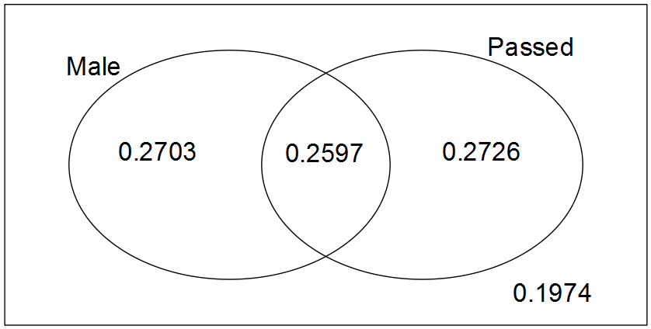25. (a)

(b) (i) 0.5323
(ii) 0.2726
(iii) 0.51
(iv) 0.8026 [7]

26. The particle’s initial displacement is 5 m to the right of the origin.
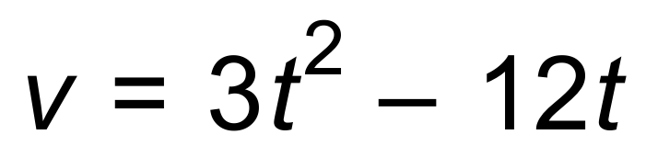 ∴ Initial velocity = 0 [2]

